**docket**

**WEEK 5 ROLES:** Irene H. - Interface Ke X. - Documentor Jessica Z. - Facilitator

**Word Count:** 2500

**INTRODUCTION**

“Bringing ideas to life”

For people of all demographics and career paths, the bustle of everyday life leaves little time and energy for personal side projects. **docket** is a public platform that tracks the progress of projects and allows users to support one another’s projects for inspiration and motivation. Through documentation and social interaction, **docket** aims to keep users accountable for the success of their own and of others’ projects.

In this assignment, we sketched out and constructed a lo-fi prototype of **docket**.We then tested **docket** on three users to evaluate our interface design and task flow. The following report details our process and results.

**SKETCHES**

10526637_10206061800436455_2070202348_n.jpg12167312_10206061802436505_802533827_n.jpg12177944_10206061801516482_466434632_n.jpg12178049_10206061800236450_99086239_n.jpg12179058_10206061799996444_2049681007_n.jpg12179543_10206061802116497_1396525803_n.jpg804584_10206061801756488_1870774512_n.jpg

**TOP TWO INTERFACES**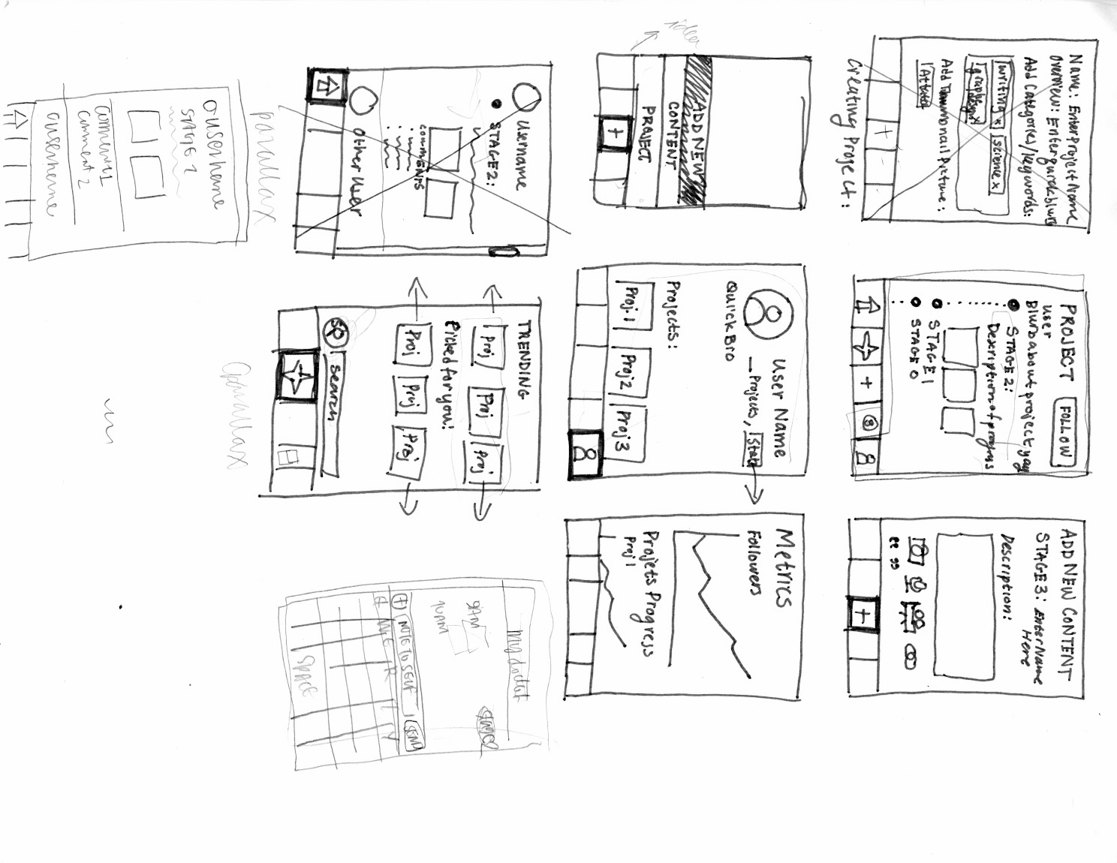

(interface 1)

Interface 1 has a menu concept that allows users to navigate from page to page, specifically through their feed, to the explore page, to the “add” page and to the user page.

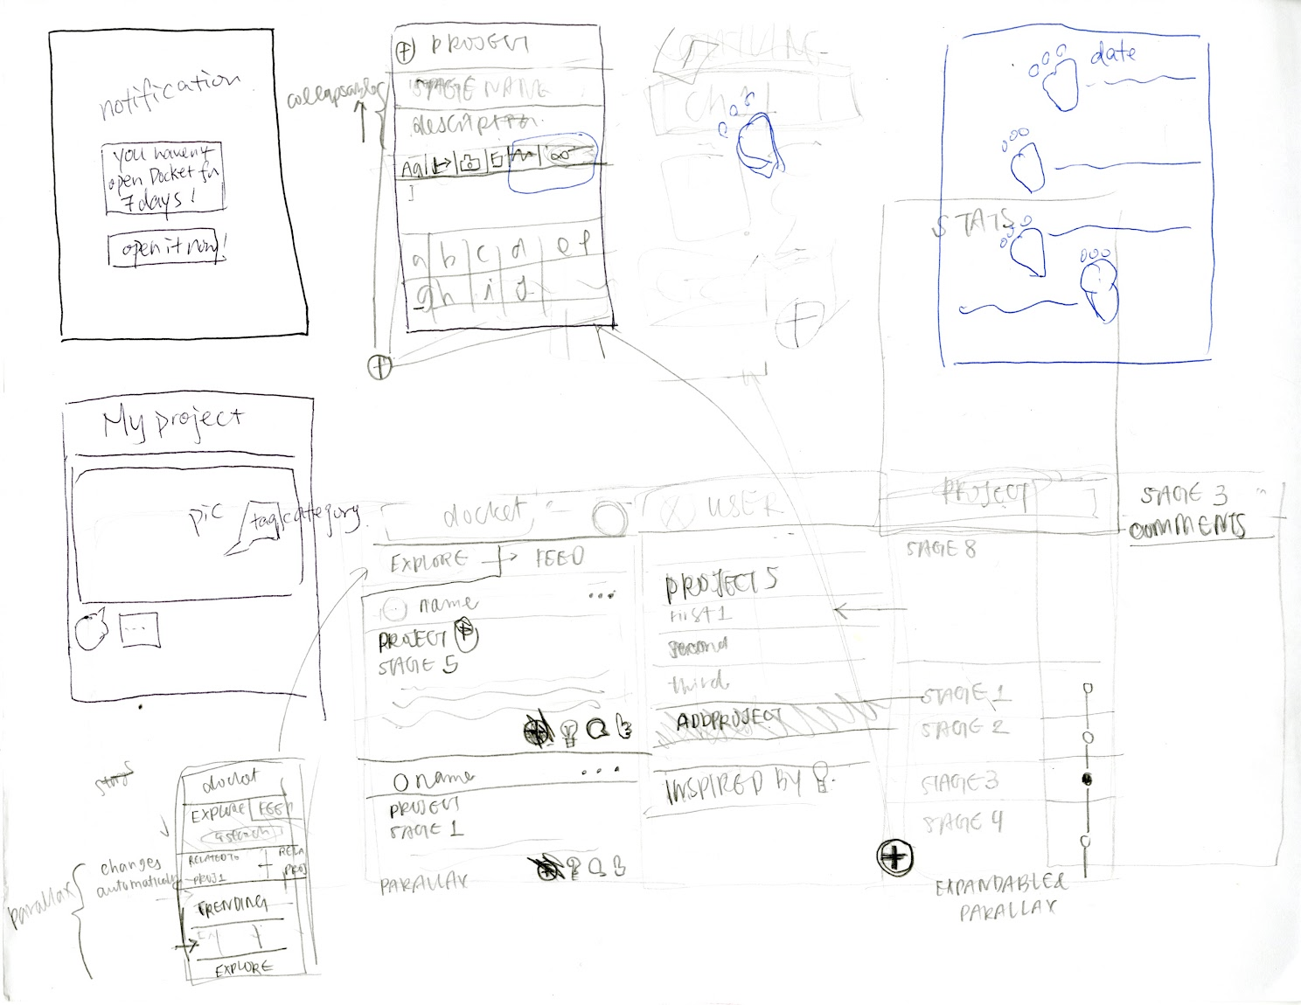

(interface 2)

Interface 2 is swipe-based to get from screen to screen; various screens are pulled down, up, left or right via tapping on a button. Interface 2 is designed around more content.

**SELECTED INTERFACE DESIGN**

We selected interface 2 over interface 1 primarily because of its swipe interface. Not only does it maximize screen space, but it also allows for more seamless interface interaction. Though the menu is a ubiquitous design feature in content-based app, we felt that having various buttons leading to different pages was a conceptual categorization of the pages themselves, and thus the various tasks (motivation, inspiration, documentation). We wanted to emphasize, in particular, that these three tasks are in fact interrelated, and are ultimately the trine lynchpins of creation, whether the final product is a research paper, a painting or a re-decorated room.

Motivation:

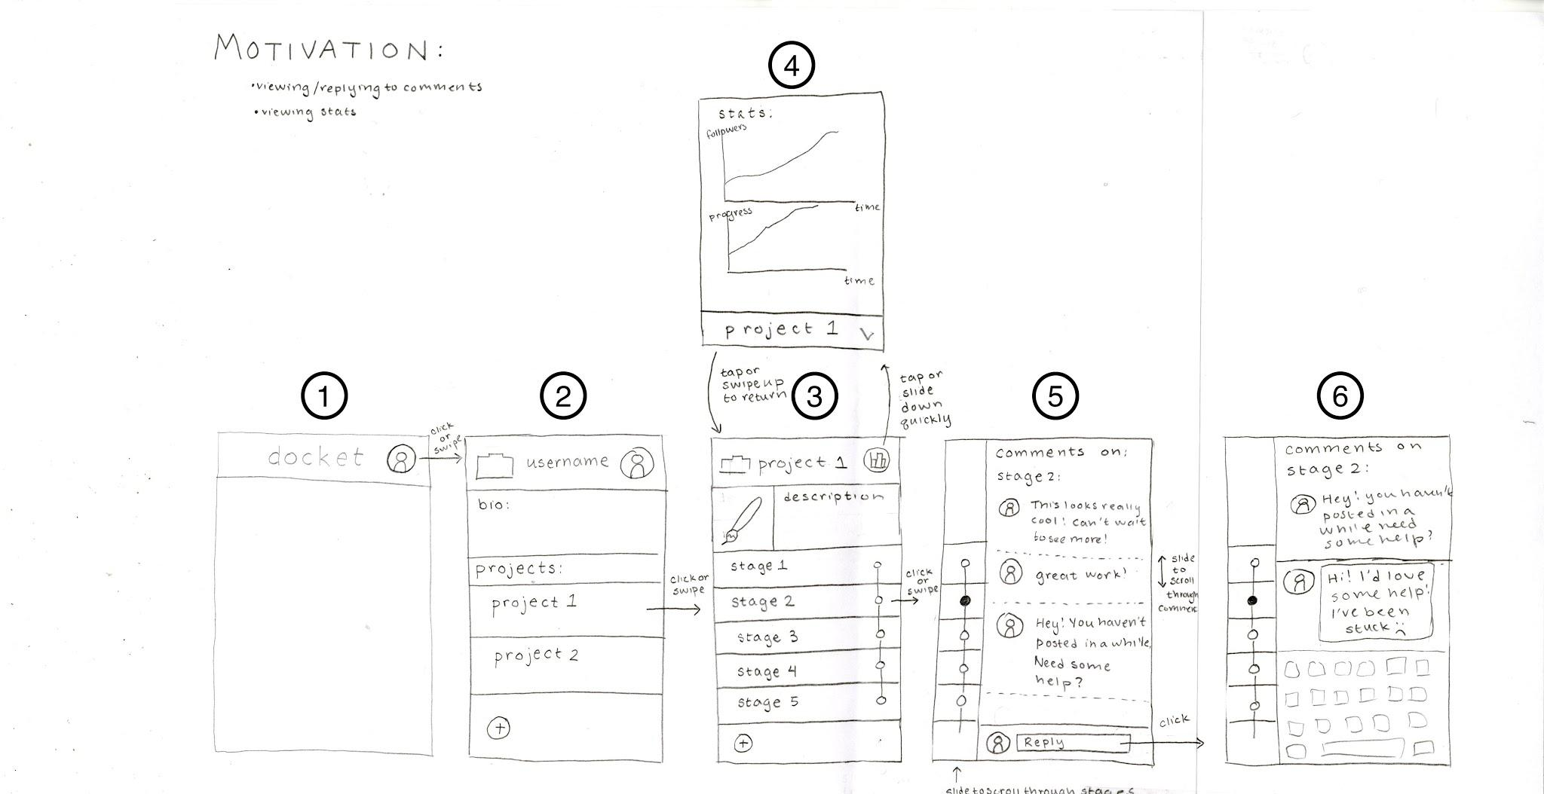

1. Starting from screen 1: To access your personal profile, click or swipe right on the user profile icon to access the personal profile page (screen 2). This page lists your projects.
2. On screen 2, click/swipe on a project to see its project page (lists the progress) (screen 3). This motivates the user by allowing them to witness their progress.
3. From screen 3, tap the stats summary icon on the top right corner to pull down the stats page on screen 4. This tracks, among other stats, the user’s followers and progress updates over time.
4. Tap on the down arrow on the bottom right corner of the stats page (screen 4) to return to the project page (screen 3)
5. From screen 3, click or swipe left on the dots on the right hand side of the page to access the comment page (screen 5). Other users can comment on the project stages, and by reading the comments, the user can receive motivation and feedback.
6. On screen 5, slide up and down to scroll through comments of each stage.
7. Click on reply at the comment page, screen 5, to pull up the keyboard and reply to comments (simulated by screen 6). This allows the user to interact with other users about the project.

Inspiration:

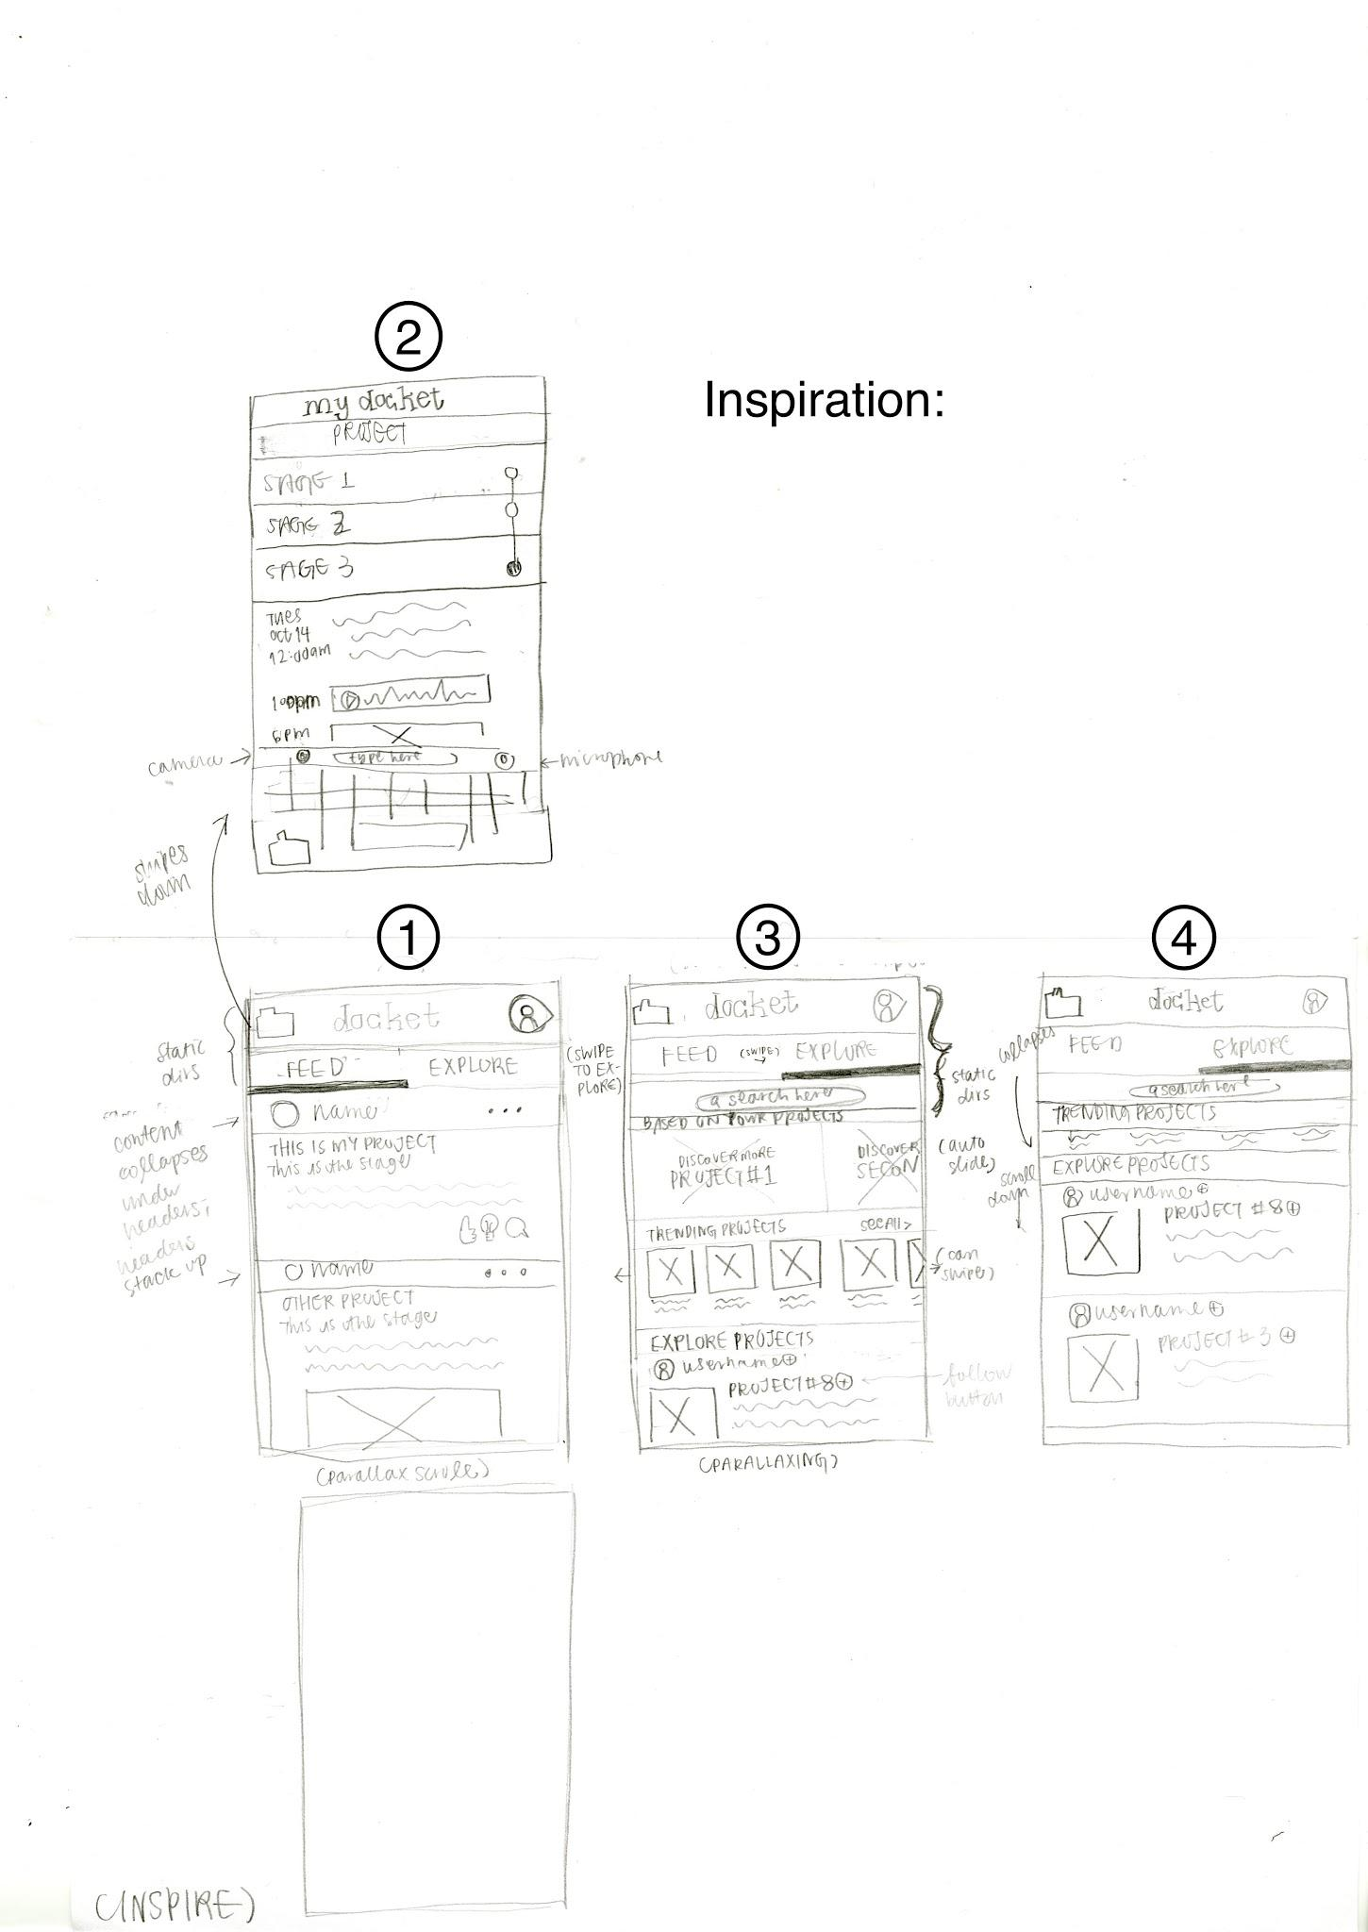

1. From the feed (screen 1), the user can scroll through different users’ project updates. They have the option to mark that they like (via thumbs-up button, which we later changed to a heart) or are inspired by (via lightbulb) a project. They can also leave a comment.
2. From the feed (screen 1), the user can swipe to the explore page (screen 3). Here, the user can swipe left and right on the projects under “Based on your projects” to discover projects related to the ones he/she is working on. The user can also swipe left and right on the projects under “Trending projects” to see universally popular projects. Finally, the user can scroll through the projects under “Explore projects” for other miscellaneous projects (simulated by screen 4). They have the option to follow a user and/or follow a project.
3. From the explore page (screen 3), the user can access his/her docket (screen 2). Here, the user can add a quick note to him/herself about his/her projects and stages **(listed as a sub-task under “Documentation” for user testing)**, and can also scroll through past notes for inspiration and to jog memory.
4. From the “my docket” page (screen 2), the user can swipe back down to the previous page.

Documentation:

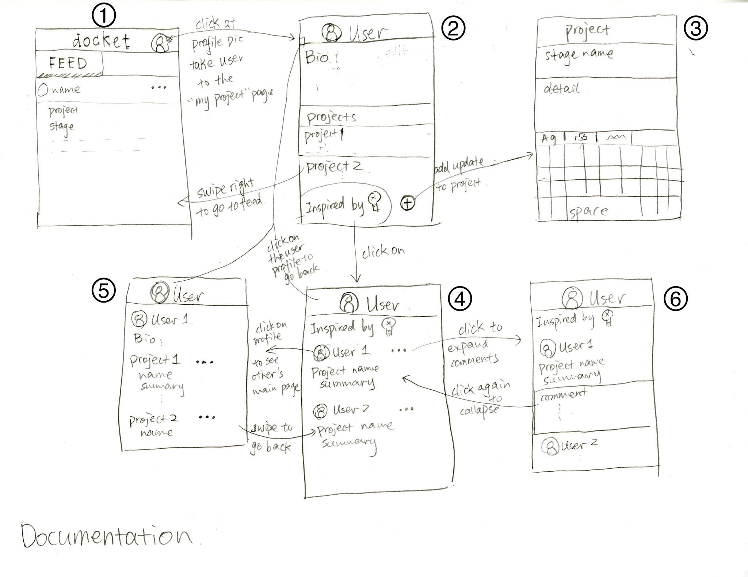

1. From the feed/explore screen (screen 1), swipe or click on the profile button on the top right corner to access the user page (screen 2).
2. From the user page (screen 2), click on the “Inspired by” button to access the “Inspired by” page (screen 4). To view more details on a project here, click on the project, which will expand on the page (simulated by screen 6). Click on users’ thumbnail pictures to access their bio pages (screen 5). **(listed as a sub-task under “Inspiration” for user testing)**
3. Return to personal user page (screen 2) by clicking on the thumbnail on the top header bar.
4. Click on the bottom right plus button to create a new project on the new project page (screen 3).

PROTOTYPE DESCRIPTION

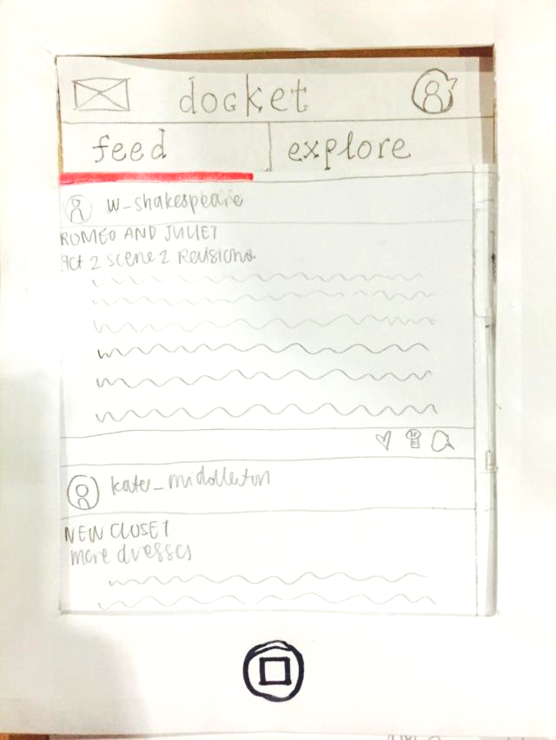 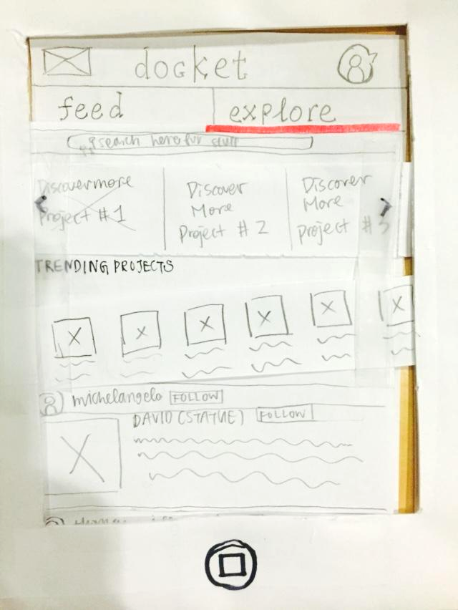

This is the main page that appears when the user opens the app. There are two sections, with the default selection as the feed. The feed (left) displays the posts and updates from users you follow. The explore feed (right) shows three different sections: related, trending and explore. Related features projects that are related to projects you are working on. Trending shows the projects that are trending on **docket**. Explore more displays random projects.

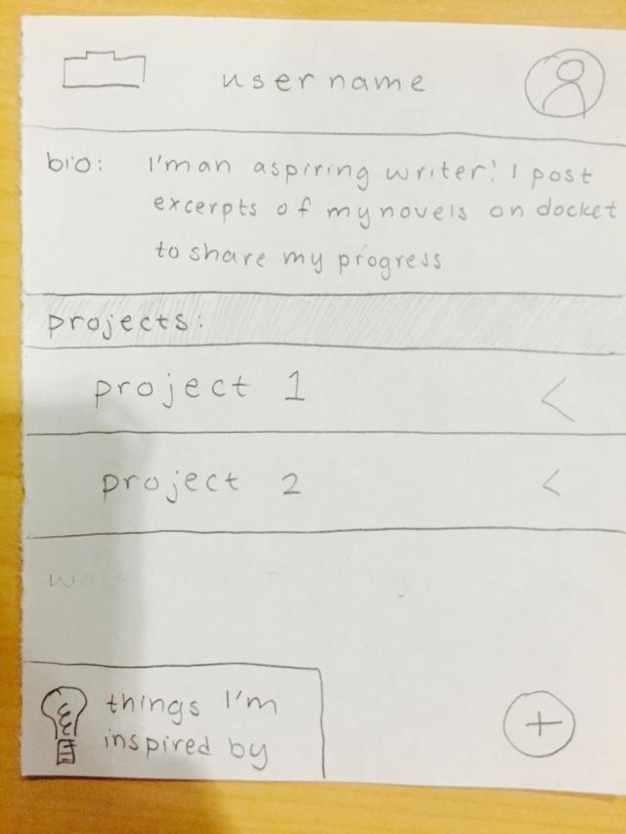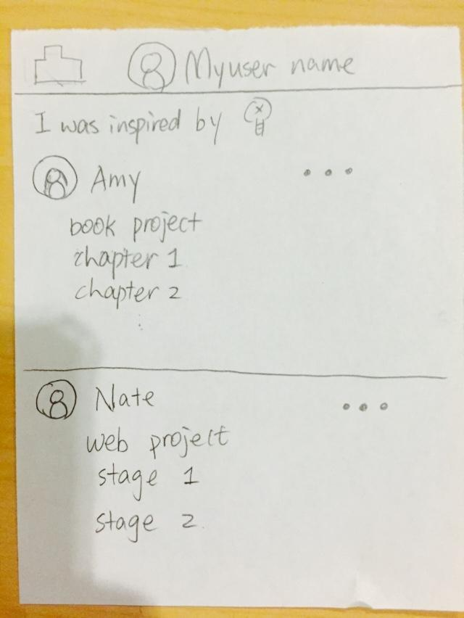

The user page of the prototype includes a short bio, a list of the projects they are working on and a button to view projects that the user has been inspired by. The add button allows the user to add a new project to their profile. The “I was inspired by” page lists the projects that the user marked as inspiring.

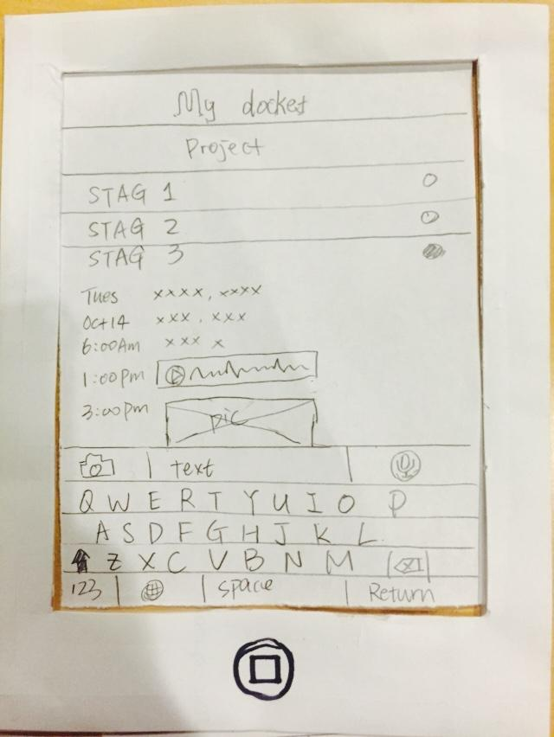

This is the docket quick-note page. It allows the user to add a quick note to themselves to any stage of their projects. Quick-notes are used to document quick ideas or thoughts rather than well-formed stages.

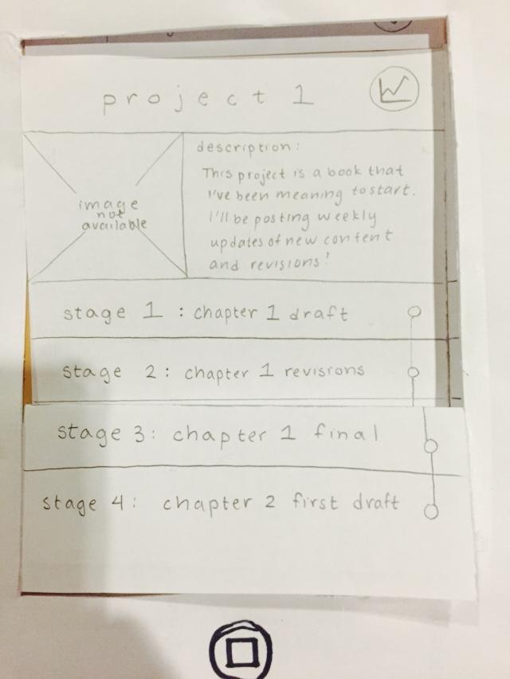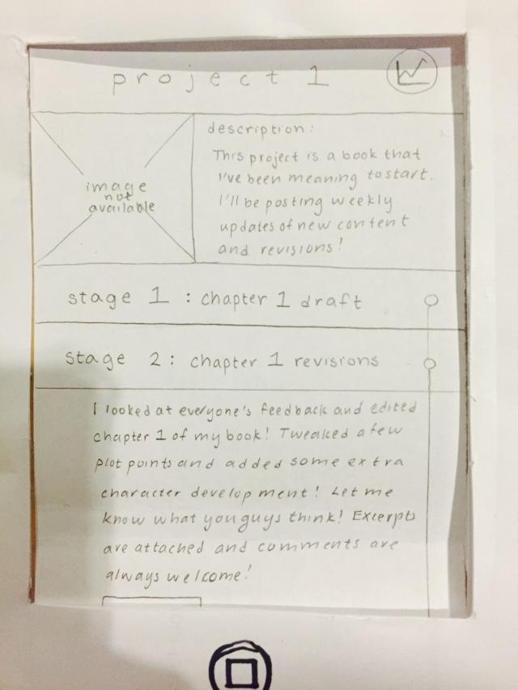

The project page provides a thumbnail image of the project and a description, and lists stages to show the progress of the project. Each stage can expand to display the details and attachments of each stage.

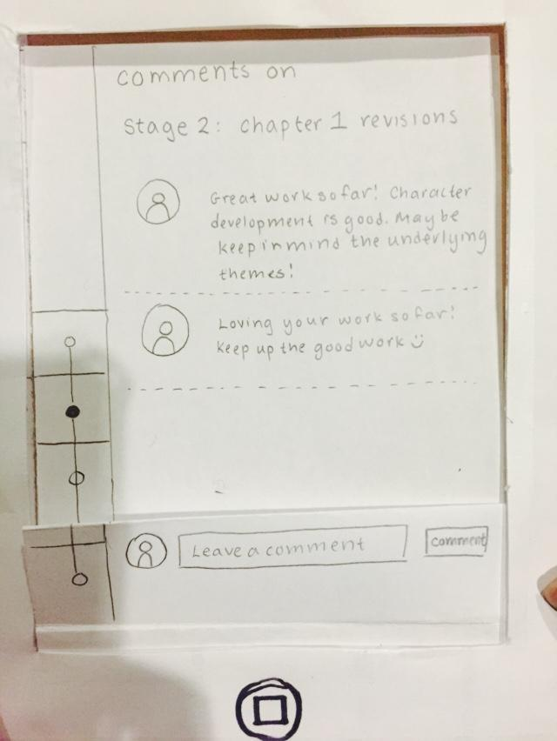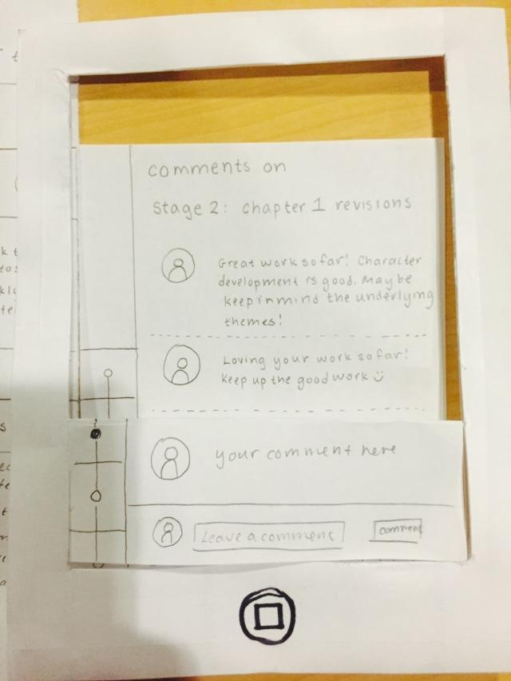

The comments pages display the comments that users have left on each stage. The timeline on the side indicates which stage the comments pertain to.

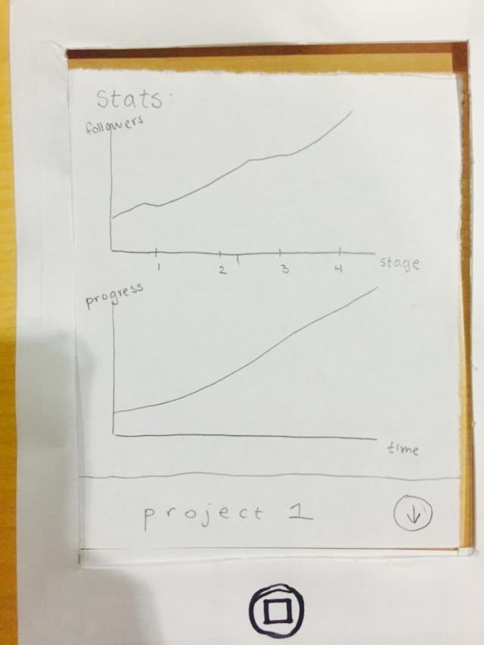

The statistics page displays the progress of the project.

**METHOD:**

**Participants:**

We chose users who were working on their own projects outside of classwork and/or their careers. We aimed to select users who were working on projects from different fields and mediums, as well as of different scales. We also selected users of various age ranges, and at different stages of their education/career.

Although we did not offer our users compensation, they were very willing to test our prototype and wanted to provide constructive criticism in order to improve the product. All of them expressed interest in using our product to document side projects in the future.

Our first user is a sophomore at Stanford University studying computer science. He works on primarily on tech-related side projects, and mentioned he does not spend as much time as he would like on his projects.

Our second user is a junior at Stanford University. She has worked on art-related side projects in the past and will begin a graphic novel as part of Stanford’s Storyboarding club.

Our third user is a software engineer at Google, Inc. He was formerly working on expanding a thesis into a book in addition to work, though he noted his progress on the side project has recently been slowing down.

**Environment:**

The testing took place in a table booth on the first floor of Arillaga Dining, the second at a table outside Tresidder Union and the third on a large conference table in Arillaga Dining, respectively. Users were all seated at an empty table with the prototype laid out in front, and a singular smartphone frame to indicate the active screen. The user was seated opposite of the facilitator and next to the computer.

**Tasks:**

During testing, Irene acted as the smartphone, Jessica acted as the facilitator and Ke documented the testing. Before testing on users, our team practiced the simulation, Ke as the participant, Irene and Jessica practicing their roles. When preparing our script, we broke down each task into subtasks. For our first task, “inspiration,” the user would be instructed to navigate their feed and mark posts. They were instructed to explore projects related to their own projects, trending projects and explorable projects; then they followed a project they were interested in, and looked through projects they had previously been inspired by. For the second task, “motivation,” the user was asked to first view the statistics on their own project and then check the comments on a stage of their project. They were then instructed to leave a comment on a stage of someone else’s comment. For the final task, “documentation,” the user was instructed to add a quick note to themselves, create a new project, and then create a new stage on the project.

**Procedure:**

Before beginning each testing, we gave the users a quick overview of interactions they could make with the prototype, introducing swiping and tapping. We also asked each user to briefly describe their recent personal projects. We asked the users to think out loud as they navigated our interface and kept note of what they thought was intuitive and what they found hard to understand. After the interview, we asked questions about how they felt about the prototype overall, what they liked, what they disliked, what confused them and if they were likely to use the product in the future. We also asked the users to explain their understanding of the purpose of different features of our prototype, and compared their responses to the actual planned functionality of the product.

During the test, we looked at how quickly the user could find what he/she was looking for, how intuitive the gestures and page flow were, and how well he/she understood the buttons and pages he/she was accessing. We measured this by noting how many tries it took the user to perform each task, how long it took the user to transition from page to page and also taking note of the user’s comments on functionality and purpose of different pages and buttons.

**RESULTS:**

**Subject 1:**

For the first task, User 1 performed all the inspiration subtasks. He found the “like” (heart) and “inspired by” (lightbulb) icons intuitive and smart. Transitioning between tasks was difficult. After he viewed the projects he was inspired by, he was unable to return to the previous screen. Swiping back did not seem intuitive to him; he expected a “return” button. The “motivation” task went smoothly. The final task, documentation, proved more difficult than the rest. User 1 was unable to recognize the icon used to add a note; by process of elimination, he eventually found the quicknote button. He then completed “documentation” without any issues.

**Subject 2:**

User 2 performed all the “inspiration” sub-tasks without a problem; like user 1, user 2 understood the “like” and “inspired by,” and was able to parse through the various categories of project exploration under the “explore” page. For the “document” sub-task, she had trouble finding the “quicknote” button on the top left-hand corner of the page. She added a quicknote successfully, but had further trouble returning to the user page from the quicknote page. When she accessed the project page and added a new stage, she noted confusion between the quicknote page versus the new stage page. The “motivation” sub-tasks were completed without any issue; the user successfully accessed the comment page through the three dots under stage 2 and swiped back to the project page, ending the testing session.

**Subject 3:**

User 3 performed the “inspiration” sub-tasks without a problem, and was eager to click on different project pages from his feed and from his explore page. He had trouble locating the button to access the user page. Like the previous two users, he had trouble finding the quicknote button, and also thought the plus button for adding a project stage was said button. Other than that, he proceeded smoothly, intuiting that he had to swipe from the quicknote to access the user page, as well as from the “add project stage” back to the project page. He performed the “motivation” sub-tasks quite easily, with the exception of trying to return to the project page from the comment page on the first try--intially, he tried to click on the timeline indicator on the left hand side instead of swiping back to the project page. The second time he accessed the comment page, however, he learned to swipe back.

**DISCUSSION:**

The most error-prone interaction with our interface was returning to the previous page; especially for vertical swipes, our users constantly looked for a return button, rather than swiping up or down to return. We are unsure whether this gesture of swiping would be learned over prolonged usage, but it seems that the best solution may be to include an explicit return button. It is important to note that users had less problems with horizontal swipes; we believe that as we move on to constructing medium and high fidelity prototypes, as well as the final interface, showing the animation for page transitions will clarify for users that swiping is the main gesture for navigating pages in all directions.

Another confusion that emerged during user testing was between the “quicknote” page and the “add stage” page. This confusion quickly turned into enthusiasm (expressed verbally) when the users caught on that each page had a separate functionality and purpose. Regardless, there are several things we can improve to reduce this confusion. The first is to improve the visual aspect of the icons; all three users thought the folder-and-plus icon delineating “quicknote” was something else (user 2 thought it was a podium; user 3 thought it was a battery). Users gave us several suggestions for improving the design of this icon; for instance, having a pen on paper icon, or having another plus button. The second improvement would be to change the location of the icons; perhaps a logical placement would be to make the quicknote icon available on the top bar on all pages, and to have the plus icon indicating the “add stage” functionality only on the project page.

Our users were also initially overwhelmed by the “Explore” page; upon looking more closely, however, they had no problem navigating between the different sections (“Related,” “trending,” “general exploration”).

Moving forward, we also hope to improve on our icon design and consistency of the icon placement throughout all pages. Since the process of creation is complex, often alternating fluidly between the three tasks, we still aren’t sure how a user would fare in using the interface while working through a project. How often would the user have to swipe between pages? Would the interface become unwieldy in the creation process? Another important element we weren’t able to test was users’ gesture recall for navigating the app over time; would gestures to access different buttons and pages become intuitive? These are things we hope to test with future prototypes, perhaps even returning to test with these users to see if they recall their gestures.

**APPENDIX:**

1. **Consent Form**
2. **Script**
3. **User Testing Data**

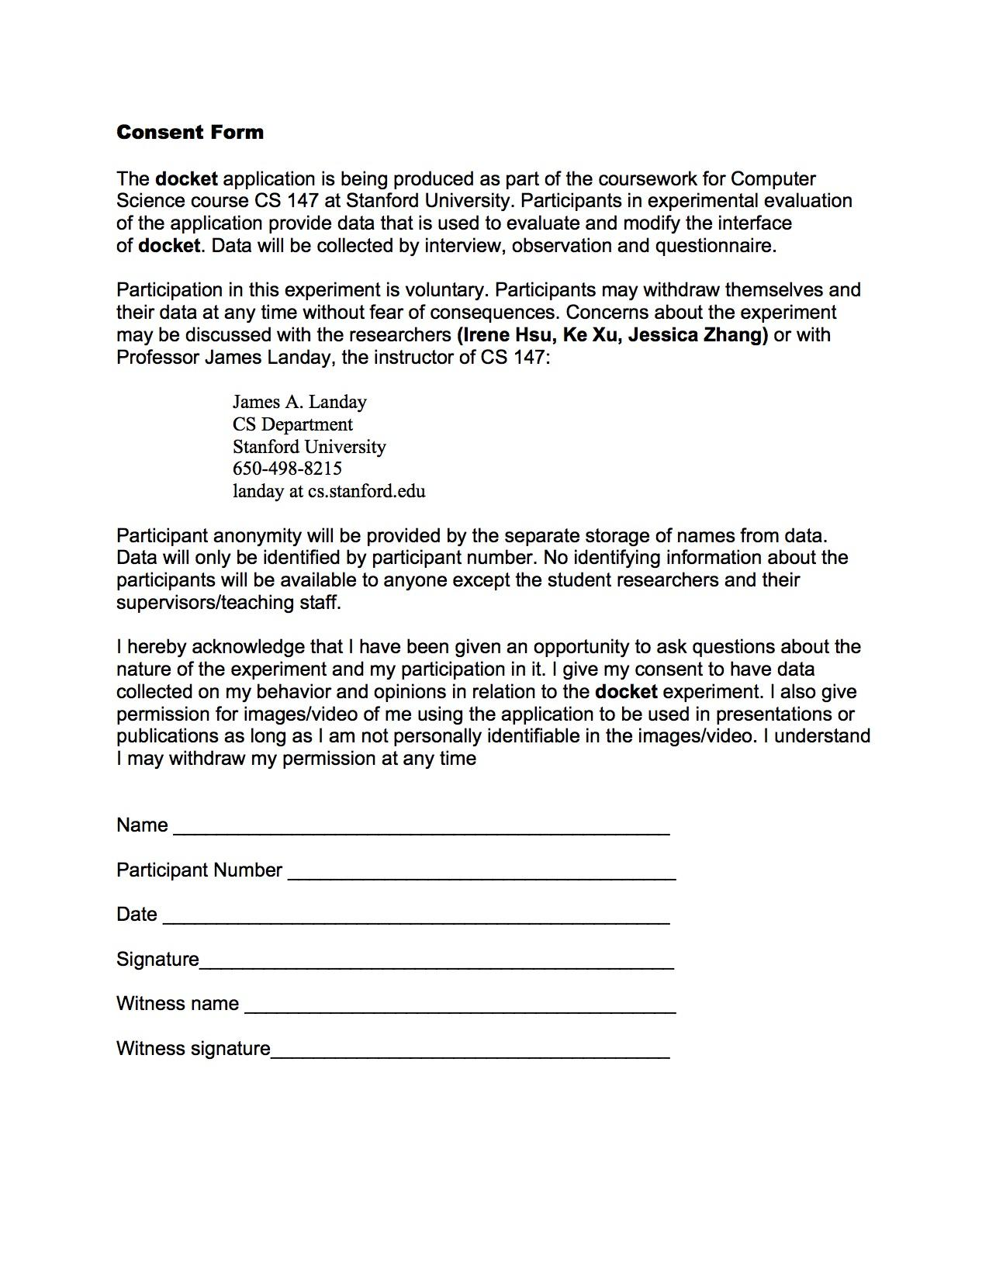

**Script**

Hi, thanks for helping to test **docket**, a public platform that helps document the progress of projects. Before we get started, could you please sign the consent form and answering the following question: Are you currently working on any side/personal projects? If so, please describe briefly?

We’re going to ask you to perform a few tasks--please think out loud as you navigate our interface so that we understand the actions you are performing and the thoughts going through your head.

Please open up the app.

(INSPIRE)

You are a user looking for inspiration.

Please navigate your feed and mark the projects your like and/or are inspired by.

Please navigate to your explore page

Look through the various projects related to your project.

Look through the trending projects.

Look through other explorable projects.

Follow a project from the explorable projects.

Now, please go to your user page.

Please look through previous projects you were inspired by.

(DOCUMENT)

Now, you are a user looking to document your project.

On any page, document a note to yourself by adding a quicknote to your docket.

Now, navigate to one of your personal projects.

Create a new stage on this project page.

(MOTIVATE)

Now, you are a user looking to motivate yourself.

Navigate to one of your personal projects.

Check the stats of this project.

Return to the project page.

Check the comments of stage 2 of your project.

Return to the project page.

Look through the progress of your project.

Now, you are a user looking to motivate someone else.

Pretend project page is another user’s.

Read stage 2 of the project page.

Navigate to the comment page of stage 2.

Leave a comment.

THANK YOU!